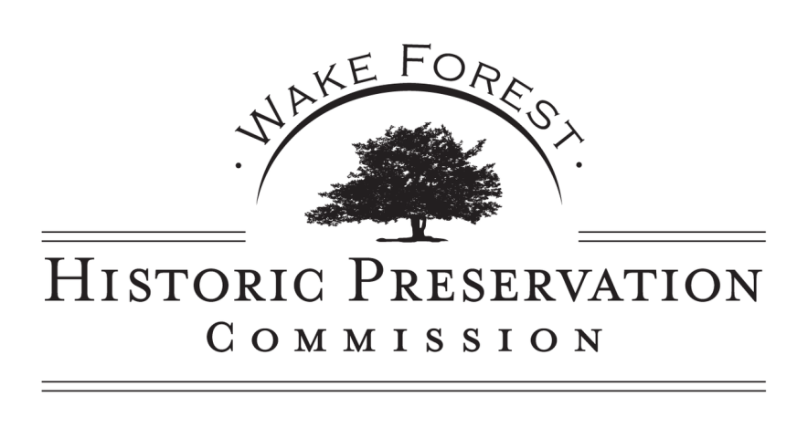
AGENDA
WEDNESDAY, JULY 10, 2019
6:30 PM REGULAR HISTORIC PRESERVATION COMMISSION MEETING
GROUND FLOOR TRAINING ROOM, TOWN HALL
301 S. Brooks Street, Wake Forest, NC

6:30 pm Regular Business
- Call to Order/Roll Call

- Approval of the Agenda

- Approval of Minutes of the June 12, 2019 Regular Meeting.

- Public Comment (limited to 3 minutes per person) The HPC is interested in hearing your concerns, however, speakers should not expect Commission action or deliberation on subject matter brought up during the Public Comment segment. Topics requiring further investigation will be referred to the appropriate Town Staff and may be scheduled for a future agenda. Thank you for your consideration of the Historic Preservation Commission, staff and other speakers.

- Treasurer’s Report

- Old Business
  - Update on Mill Village Information Meeting held June 13, 2019
  - New Budget
  - Training-Updated Design Guidelines
  - Overview of HPC Projects 2014-2019

- New Business and Announcements
  - Other Business and Announcements

- Adjourn

