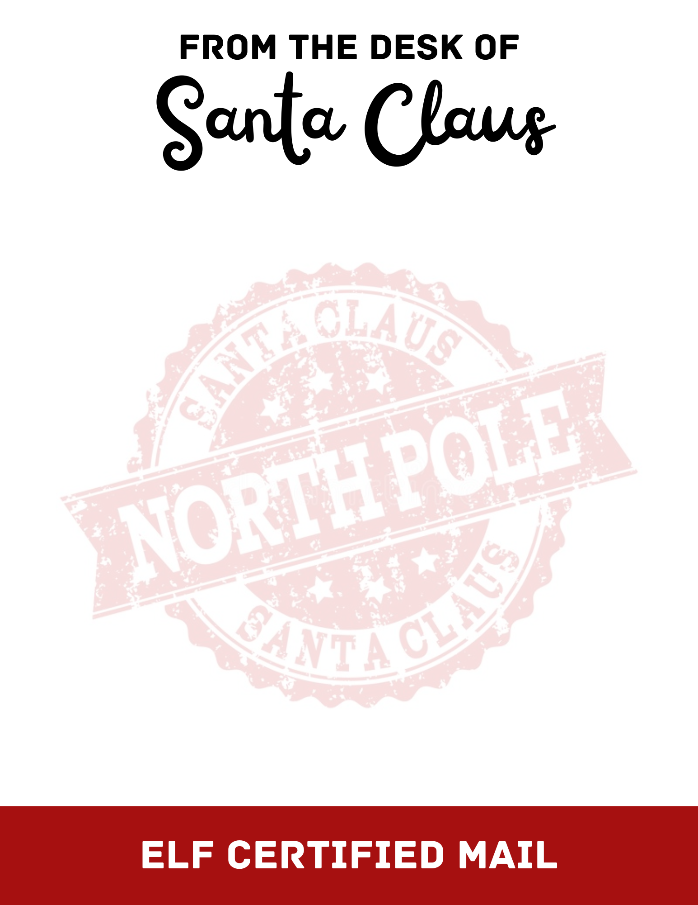

Dear [Insert Name],
“Ho! Ho! Ho!” from the North Pole! Mrs. Claus and I have been having so much fun reading letters from children all over the world, especially yours! She says hello, by the way.
The elves have been working hard this Christmas season and I’m so proud of them! During their breaks from making toys, wrapping gifts, and packing my sleigh, they enjoy building snowmen and snacking on scrumptious holiday cookies and candies with a big glass of eggnog.
I hear you've been kind, generous, and thoughtful to your friends and family this year. Remember to greet everyone with a smile. Don't forget "please" and "thank you." Lend a helping hand. These things make people happy and that's what I want to do for you on Christmas morning.
Remember to go to bed early on Christmas Eve, because I only stop by when children are fast asleep in their beds. The reindeer and I will try to be very quiet when we stop by, but please remember to leave us a little treat.
Merry Christmas and Warmest Wishes,
Santa Claus
CHECKED TWICE AND SIGNED BY

