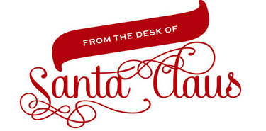

Dear friend,
Greetings from the North Pole! Mrs. Claus, the elves and I are so happy when we receive letters from our friends. I was just enjoying some hot cocoa and warming up by the fireplace after a long day in the workshop.
The elves have been busy working extra hours to make sure everything is just right for Christmas Eve. Rudolph has been polishing his nose and leading the other reindeer in daily workouts, so that they will be in tip top shape. Funny thing, as Christmas gets closer, the reindeer are getting more and more excited!
I am looking forward to making my trip around the world and can't wait to visit your home. I hope you have you minded your manners and tried to be good; and been thoughtful of others as everyone should. All that flying and unloading of toys is hard work and makes us hungry, so please be sure to leave out some special treats for the reindeer and me.
Thanks again for writing, but I must go to bed now. I have another full day at the workshop tomorrow and need to make sure I have started on your presents.
Be healthy, be happy, and keep wearing a smile, as Christmas will be here in a very short while!

Ho! Ho! Ho! Merry Christmas,
Santa Claus

